Implementation of Password Cracking and Secure Hashing Mechanisms

1. Introduction
Passwords are widely used for authentication in computer systems. However, weak passwords and improper storage techniques make systems vulnerable to attacks. This project demonstrates password cracking techniques and secure hashing mechanisms using Kali Linux.

2. Objectives
1. Demonstrate password cracking using dictionary attacks
2.Implement hashing in Python
3.Apply salting for enhanced security
4.Compare security before and after hashing

3. Tools Used
1.Kali Linux
2.John the Ripper
3.Python

4. Methodology
1. Created a password file with weak passwords
2. Performed dictionary attack using John the Ripper
3. Generated hashed passwords using Python
4. Applied salting to passwords
5. Compared results

5. Implementation

5.1 Password File
Example:
ali:123456
ahmad:password
sara:qwerty
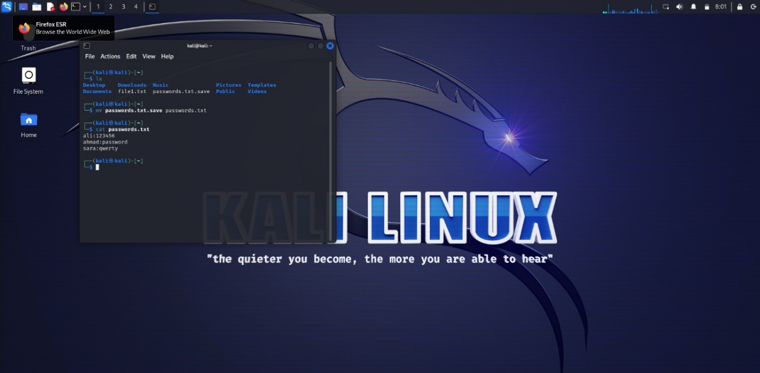

5.2 Dictionary Attack
Using MD5
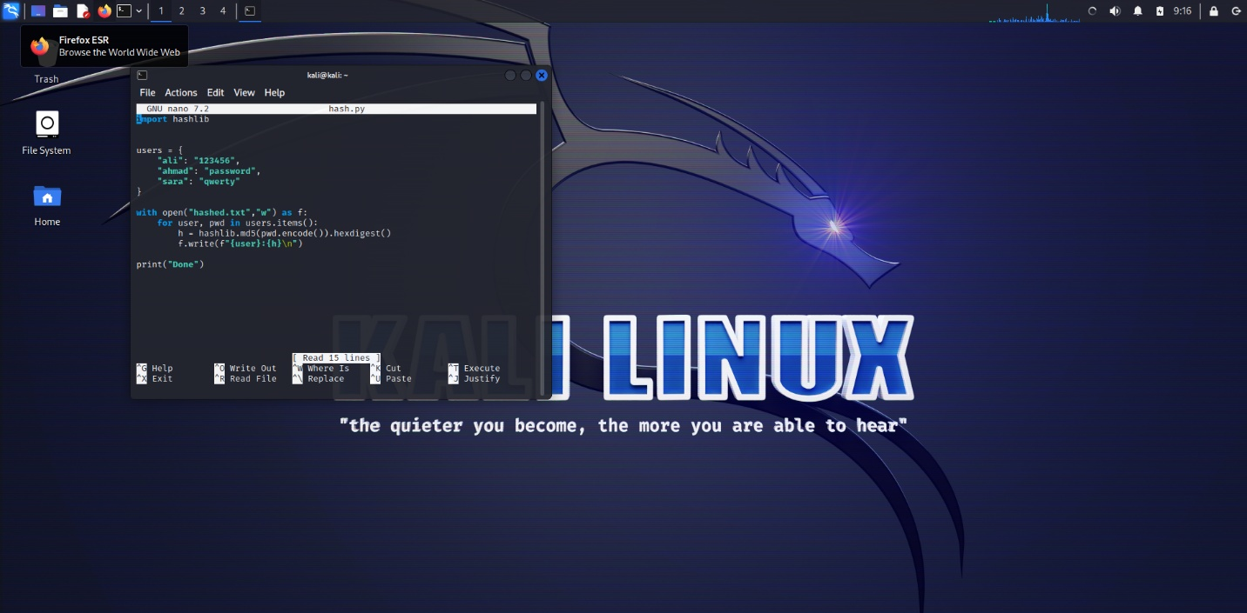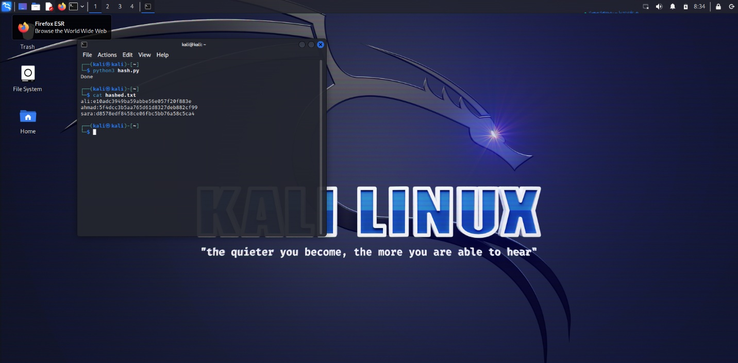
Command:
Using john the Ripper
john –format=raw-md5 --wordlist=/usr/share/wordlists/rockyou.txt hashed.txt
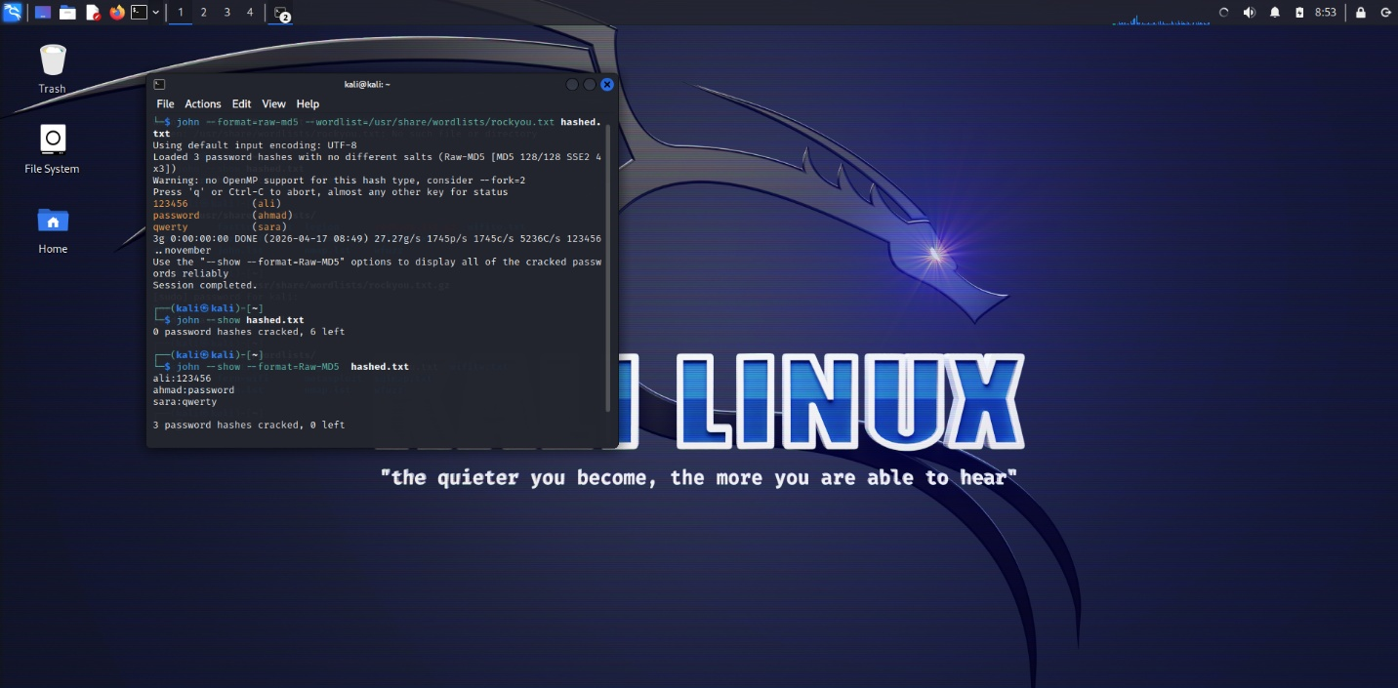

5.3 Hashing using Python (SHA-256)
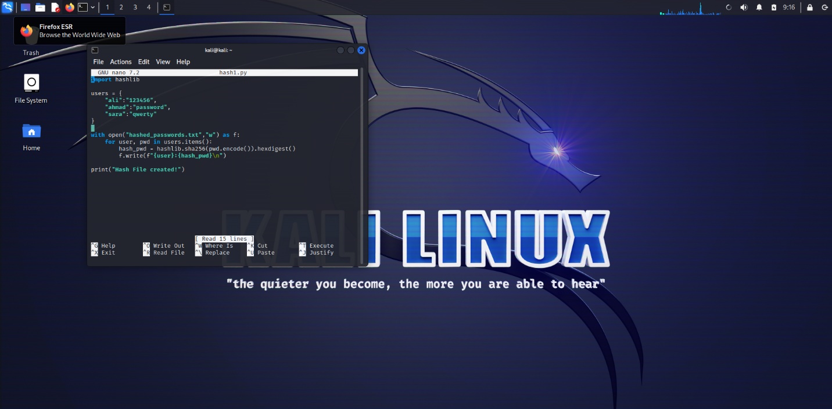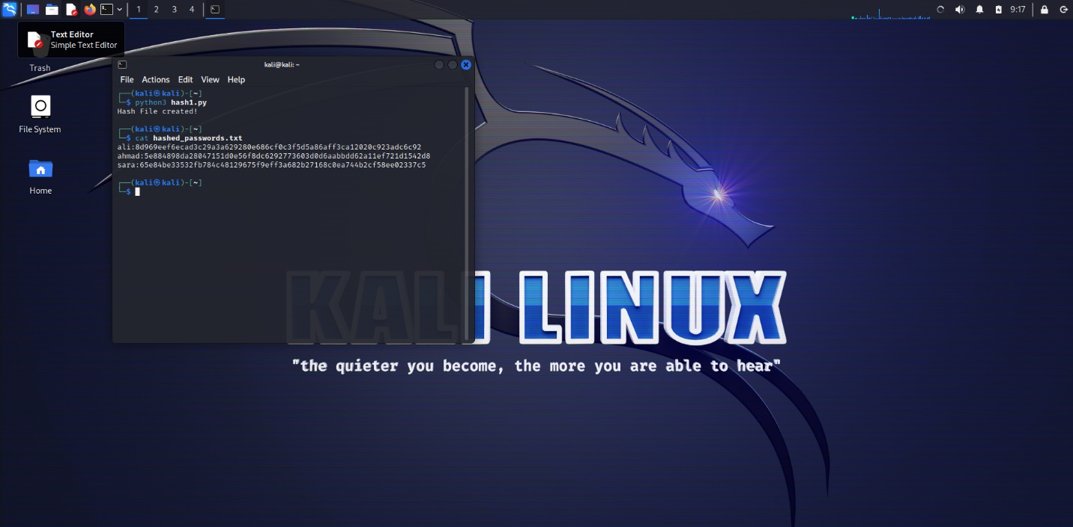
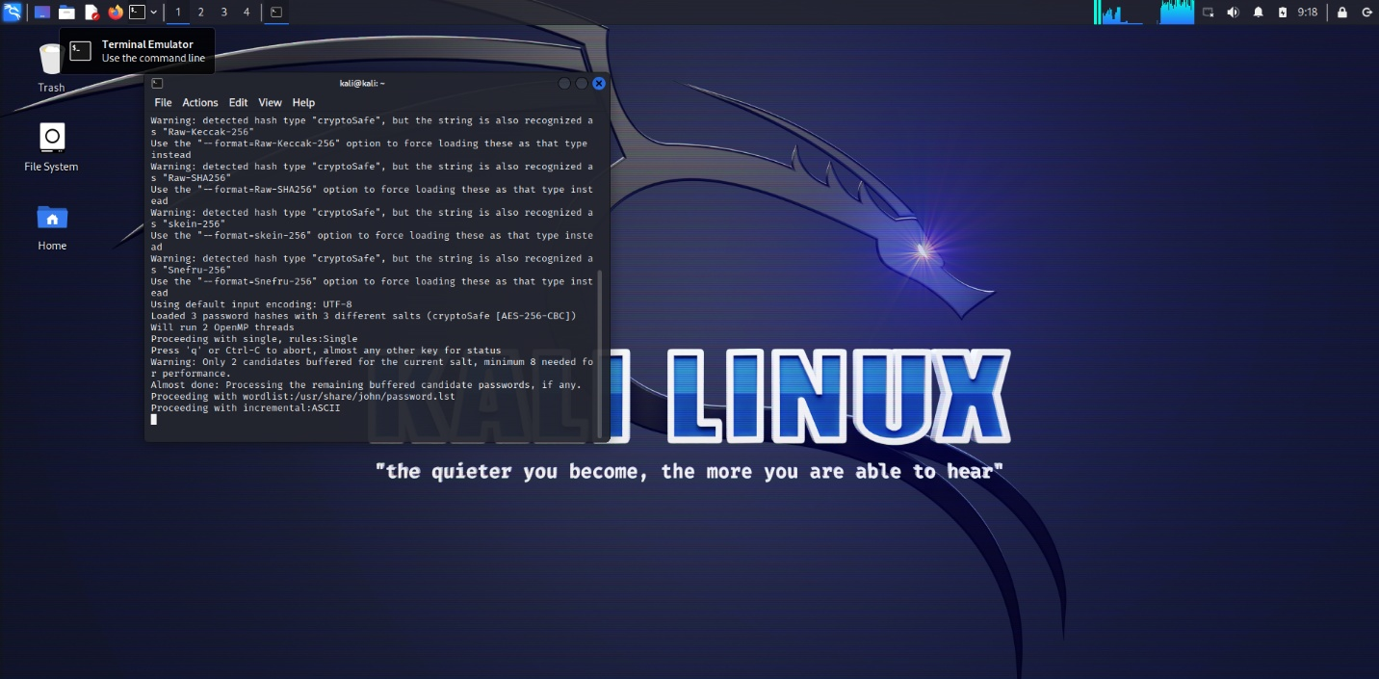

5.4 Salting
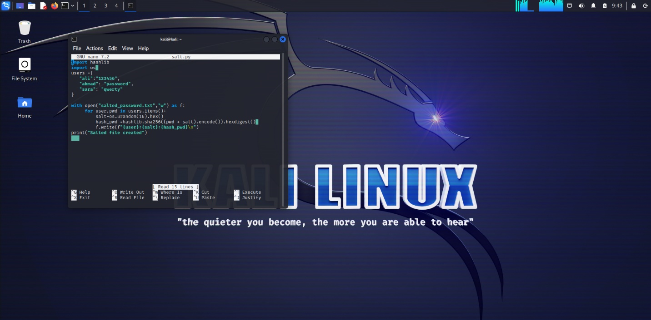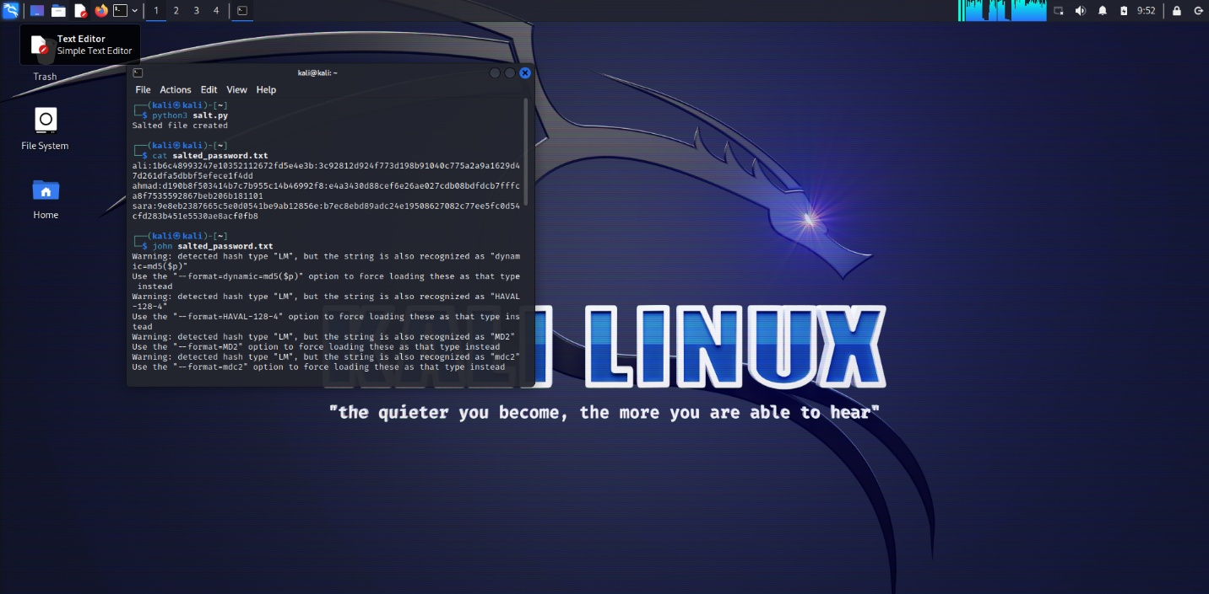
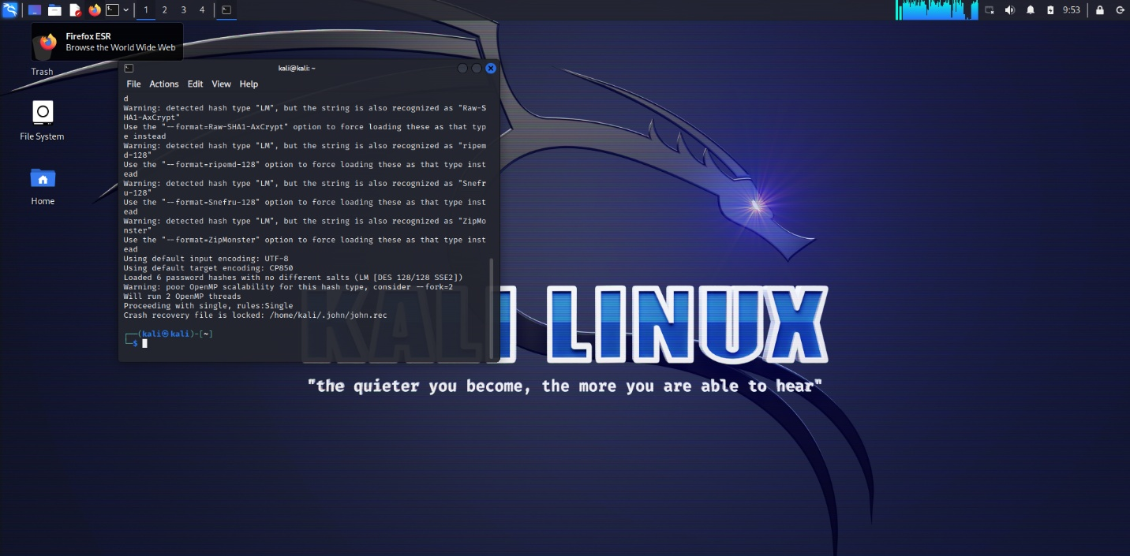

6. Results
Plain Text: Easily Cracked
MD5: Cracked
SHA-256: Difficult to Crack
Salted Passwords: Highly Secure

7. Conclusion
This project demonstrated that weak passwords can be easily cracked using dictionary attacks. MD5 hashing is weak and can be cracked, while SHA-256 provides stronger security. Salting further enhances password protection.

